**HALL ADDER USING ONLY NAND GATE**

**EXP NO:17**

**AIM:** To design and implement half adder using only NAND gate with Logisim simulator.

**ALGORITHM:**

1. Connect the inputs to the NAND gate.
2. Start the connection according to the logic diagram, finish it reaching the designated inputs.
3. Connect the outputs to the gates
4. Check and verify the truth table accordingly.

**DIAGRAM:**

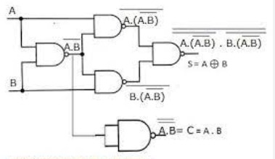

**TRUTH TABLE:**

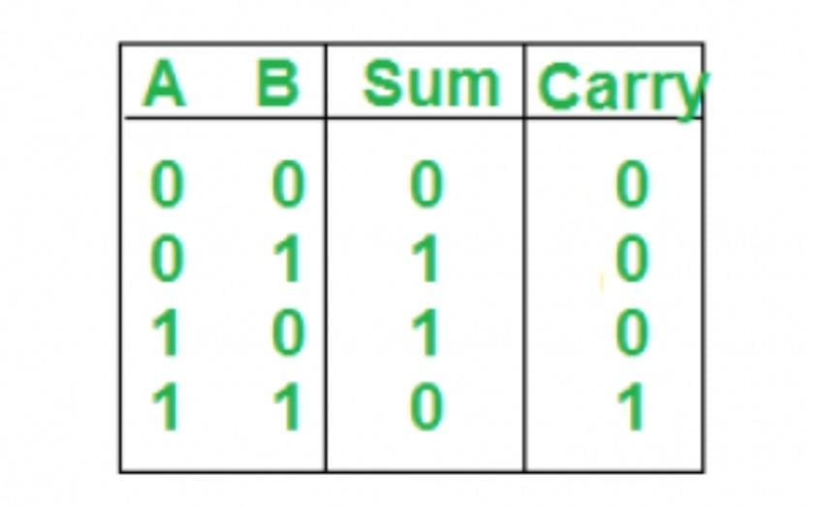

**OUTPUT:**

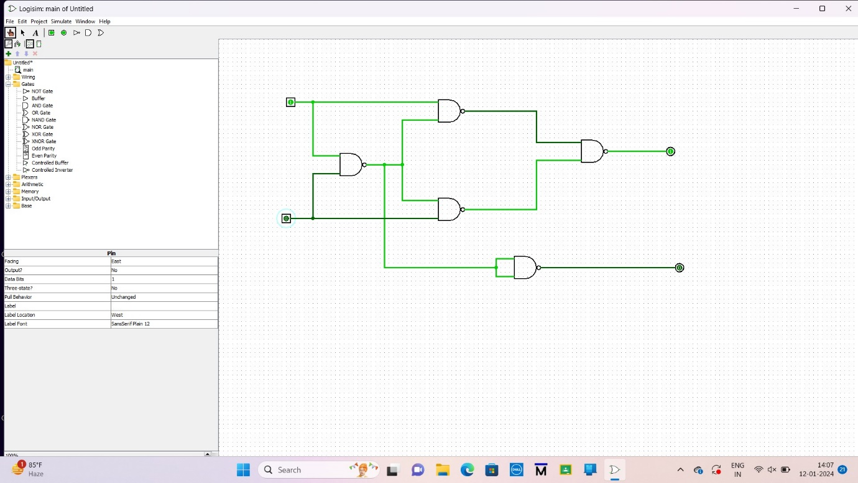

**RESULT:** Thus the implementation of half adder using only NAND gate with Logisim simulator was executed successfully.